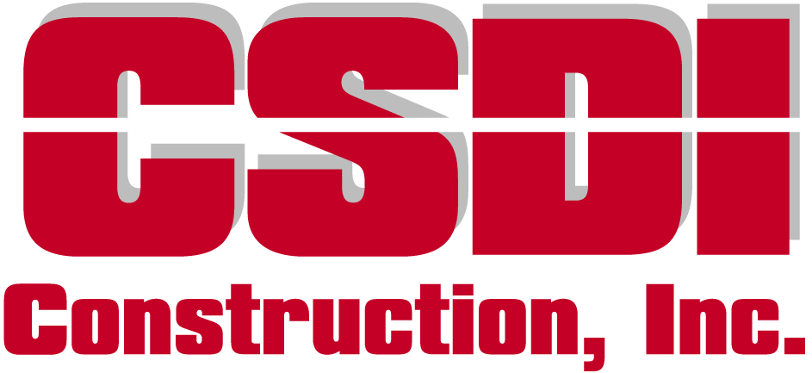

Position Title: Project Manager
Draft Date: 02-25-2022
Reports to: Construction Manager

Position Purpose: Facilitate all aspects of commercial construction projects from start to finish meeting quality, time and financial targets. Our project managers are integral contributors to our bottom line, and they are proud to take responsibility for their builds.

Principle Accountabilities and Essential Duties and Responsibilities:
- Overseeing CSDI Superintendents, and all subcontractors during construction on multiple projects simultaneously.
- Controlling project income and expenses, budgets and actuals in adherence to company accounting policy and controls.
- Meeting all requirements set forth by local governments, owners, and landlords to assure successful project completion and adherence to code.
- Communicating progress or issues with management and owners regularly.
- Consulting with CSDI Estimators during project bidding and budget creation. Assisting with estimating as business demand requires.
- Establishing lasting relationships with customers, and generating new valuable clients for CSDI.

Knowledge, Skills and Abilities:

Comprehensive knowledge of:
- All aspects of commercial building construction activities
- Interpretation skills for commercial design drawings and specifications
- The uniform building codes
- Leading and working with diverse groups of people
- Professional and concise communication skills
- Safety regulatory requirements for projects assigned
- Common computer and technological communication methods including,
- Microsoft Office Suite
- Microsoft Outlook, desktop and mobile
- Video Conferencing
- SureTrak, Microsoft Project (or familiarity with similar software)

Requirements:
- Construction Management degree, or equivalent experience.
- Minimum of five years experience in field commercial construction supervision, and/or project management.
- Must demonstrate excellent communication skills when interfacing with management, involved trades, building officials, architects and owners.
- Ability to work in-office and on jobsites.
- Ability to travel occasionally out of town/state to monitor projects.

Benefits:
- The Project Manager is a full-time salaried, exempt position
- CSDI offers medical, dental, vision, life and disability insurances
- CSDI offers a 401k plan including profit sharing contributions
- CSDI has an established 30+ year history of success and fosters an excellent corporate culture of empowerment and support to all of our employees.

